SYNOPSIS

ON

“Mood Spotifier with Chatbot (MODIC)”

Submitted in

Partial Fulfillment of requirements for the Award of Degree

*of*

Bachelor of Technology

*In*

Computer Science and Engineering

**Computer Vision and Artificial Intelligence**

By

**22_AI_2A_10**

# Hari Om Shukla (2101641520067)

# Sarthak Jain (2101641520123)

# Pratham Singh (2101641520108)

# Alokik Prakash Gupta (2101641520012)

**Rishabh Singh Gaur (2101641520118)**

Under the supervision of

**Subhash Singh Parihar**

**Associate Professor**



**Pranveer Singh Institute of Technology**.

 Kanpur - Agra - Delhi National Highway - 19

Bhauti -Kanpur - 209305.

**Page No.1**

**Introduction:-**

**Music is a great connector. It unites us across markets, ages, backgrounds, languages, preferences, political leanings and income levels.**

**People often use music as a means of mood regulation, specifically to change a bad mood, increase energy level or reduce tension.**

**Also, listening to the right kind of music at the right time may improve mental health. Thus, human emotions have a strong relationship with music.**

**In our proposed system, a mood-based music player is created which performs real time mood detection and suggests songs as per detected mood.**

**This becomes an additional feature to the traditional music player apps that come pre-installed in our mobile phones.**

**An important benefit of incorporating mood detection is customer satisfaction.**

**The objective of this system is to analyze the user’s image, predict the expression of the user and suggest songs suitable to the detected mood.**

**Human emotions can be broadly classified as: fear, disgust, anger, surprise, sad, happy and neutral.**

**A large number of other emotions such as cheerful (which is a variation of happy) and contempt (which is a variation of disgust) can be categorized under this umbrella of emotions.**

**A user's emotion or mood can be detected by his/her facial expressions.**

**These expressions can be derived in the real-time live feed via the system's camera.**

**Face recognition algorithm will analyze the face of the user.**

**Image recognition technique will help to match the picture of user at real-time to the trained data.**

**Emotion Detection will be implemented using Deep learning.**

**A lot of research is being conducted in the field of Computer Vision and Deep Learning where machines are trained to identify various human emotions or moods.**

**Deep Learning provides various techniques through which human emotions can be detected.**

**With the usage of Artificial Intelligence, we can implement Chatbot.**

**Chatbot will be used to enhance user’s real-time experience.**

**Chatbot will also helps to give more accurate results as per mood of User.**

**We can create a interface for the user to interact to our application.**

**This will make an extra edge to the user’s experience on our application.**

**Keywords—Face Recognition, Image Processing, Computer Vision, Emotion Detection, Deep Learning, Music, Mood detection.**

**Project Objective:-**

**Page No.2**

**In this project, our aim is to create a music recommendation system/music player which will detect the user’s face, identify the current mood and then recommend a playlist based on the detected mood.**

**The objective of this system is to analyze the user’s image in the real-time via machine camera, predict the expression of the user and suggest songs suitable to the detected mood.** **An important benefit of incorporating mood detection is customer satisfaction.**

**In our proposed system, a mood-based music player is created which performs real time mood detection and suggests songs as per detected mood. This becomes an additional feature to the traditional music player apps that come pre-installed in our mobile phones.**

**Principal purposes of the recommender are: addressing the choice problem, exploring new music pieces, support mental and physical wellbeing and support in improving working processes. The design involves a combination of artificial intelligence techniques and generalized, music recommendation and therapy approaches.**

**It uses Chatbot to ensure the right mood is to be detected.**

**This will make user to choose the best song for the mood.**

**It also helps to take a feedback from the user in case of any inaccuracy confronted by the program algorithm.**

**We are aiming to develop the application in following steps:-**

* **It starts with a conversation between user and program.**
* **Program will take a real-time image of the user.**
* **Image will be processed and mood of the user will be detected.**
* **The detected mood will be cross-checked from the user end.**
* **If OK, then music album of related mood will be shown.**
* **One of the song will be played.**

**Hence, our program will end up by playing a special song as per the user’s mood.**

**This will make user comfortable and give relief to his/her mind by making them forget about the negative or sad part.**

**User will get relaxed and motivated. This will increase the productivity of the user. Refresh his/her mind. Give a way to move forward with a positive mindset.**

**Since our developed program is a open source program, hence, we don’t have any investment vs profit chart. This program is free to use for all users.In the development of this project, our team work very hard but our intension is not for any profit making. This program will entertain the user and give relaxation to his/her mind. This is our biggest profit.**

**Page No.3**

**Feasibility Study:-**

**Opportunities and Threats:-**

**Thus, for more accurate results it needs to be trained for more images, and for a greater number of epochs. Recommendation of movies and TV series on the basis of mood detection can also be considered as a future scope for our project.**

**Technical feasibility:-**

**The technologies used in the development of this project are AI and CV.**

**These technologies are very popular and a high level of research is going on in these fields of technology. Hence, our project has a high level of technical feasibility.**

**Operational Feasibility:-**

**Our developed program can run on browser nad hence easy to access and use.**

**Feedback system in this program enables it to operate in various conditions like extremely high or low lighting, their camera not working properly, they have a lower resolution camera which is unable to take a clear picture of their face. The user can give reply to the system as a feedback. Hence, operational feasibility of developed project is up to the mark.**

**Economic Feasibility:-**

**Our developed program is a open source program. Hence, this project doesn’t take any cost for contents and development. Since, our project has almost no investment except time, this project can be developed by any person having knowledge of technologies and emerging fields. Hence, our project has a high degree of economic feasibility.**

**Legal Feasibility:-**

**All the content used in the project is taken from open sources. There is no violation of any government laws of Intellectual Property.**

**Schedule feasibility:-**

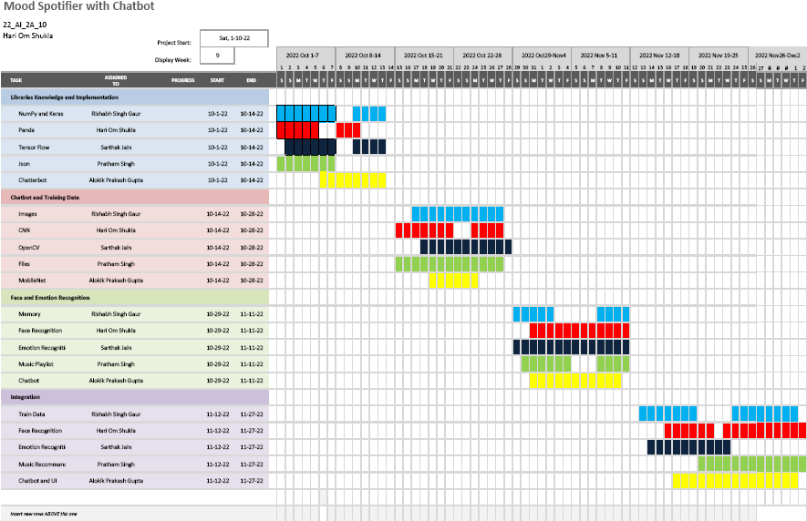

**Page No. 4**

**Methodology:-**

1. **Chatbot Module:**

**This system starts with a conversation to the user like “Hello”, ”What’s Your Mood”, ”Let me check it”, etc. It is also used for getting feedback from the user. Chatbot will be implemented in python language using Chatterbot Library.**

**ChatterBot is a Python library designed to make it easy to create software that can engage in conversation. An untrained instance of ChatterBot starts off with no knowledge of how to communicate. Each time a user enters a statement, the library saves the text that they entered and the text that the statement was in response to.**

**As ChatterBot receives more input the number of responses that it can reply and the accuracy of each response in relation to the input statement increase. The program selects the closest matching response by searching for the closest matching known statement that matches the input, it then chooses a response from the selection of known responses to that statement.**

**User Message**

**Entity**

**Recognition**

**Intent**

**Classification**

**Entities**

**Intent**

**Context**

**Responses**

**Candidate Response**

**Generator**

**Candidate Response**

**Response Selector**

**Response**

**Page No.5**

**Fig. Architectural Diagram of Chatbot**

**The mood-based music recommendation system is an application that focuses on implementing real time mood detection. It is a prototype of a new product that comprises two main modules: Facial expression recognition/mood detection and Music recommendation.**

1. **Mood Detection Module :**

**This Module is divided into two parts:**

* **Face Detection — Ability to detect the location of face in any input image or frame. The output is the bounding box coordinates of the detected faces. For this task, the python library OpenCV was considered.**
* **Mood Detection — Classification of the emotion on the face as happy, angry, sad, neutral, surprise, fear or disgust. Keras which is a CNN architecture model for Image Classification and Mobile Vision was used. There are other models as well but what makes Keras special is that it has very less computation power to run or apply transfer learning to. This makes it a perfect fit for Mobile devices, embedded systems and computers without GPU or low computational efficiency without compromising the accuracy of the results. It uses depth wise separable convolutions to build light weight deep neural networks. The dataset used for training was obtained by combining FER 2013 dataset [6] and MMA Facial Expression Recognition dataset [7] from Kaggle. The FER 2013 dataset contained grayscale images of size 48x48 pixels. The MMA Facial Expression Recognition dataset had images of different specifications. Thus, all these images were converted as per the images in FER 2013 dataset and combined to obtain an even larger dataset with 40,045 training images and 11,924 testing images. Keras was used to train and test our model for seven classes - happy, angry, neutral, sad, surprise, fear and disgust. We trained it for 25 epochs and achieved an accuracy of approximately 75%.**

1. **Music Recommendation Module**

**The dataset of songs classified as per mood was found on Kaggle for two different languages - Hindi and English. Research for a good cloud storage platform to store, retrieve and query this song data as per user’s request was conducted**

1. **Integration**

**For the integration of these two modules in an Android application, the trained Keras model was saved as an .h5 file, and this .h5 file was then converted to a .tflite file using TensorFlow Lite Converter. It takes a TensorFlow model as input and generates a TensorFlow Lite model as output with .tflite extension. Since the Keras model is used, the size of the tflite file is expected be around 20- 25 Megabyte (MB) which was the desired size. The labels.txt file contains the class labels of the model. All the appropriate methods were created for loading the model, running the interpreter and obtaining the results.**

**Page No.6**

**Below given system architecture diagrams depicts the overall outline of the software system and the relationships, constraints, and boundaries between components.**

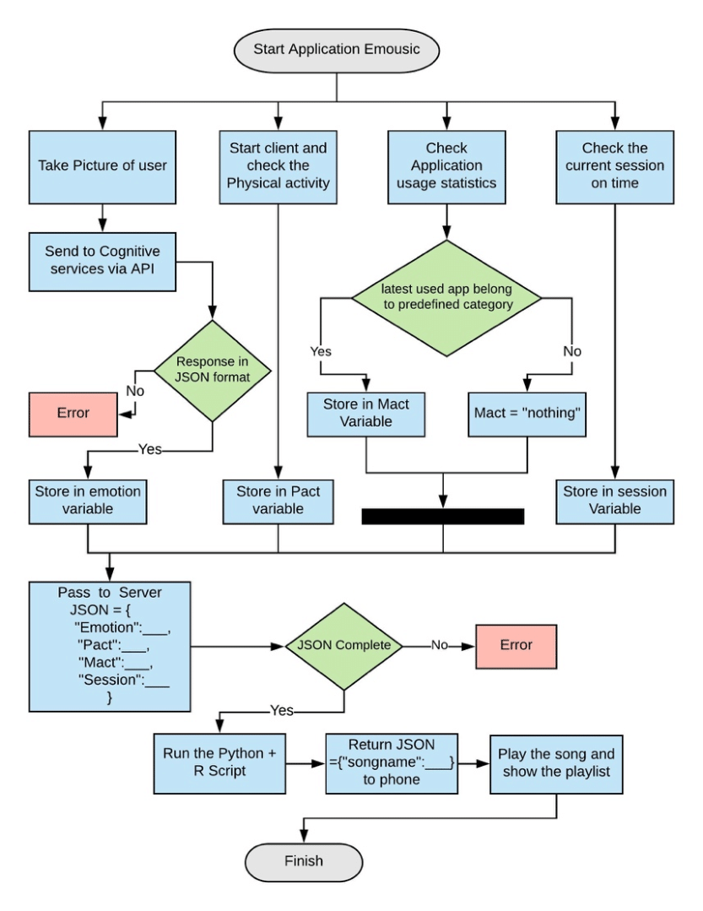

**Fig. ER Diagram of Project**

**Page No. 7**

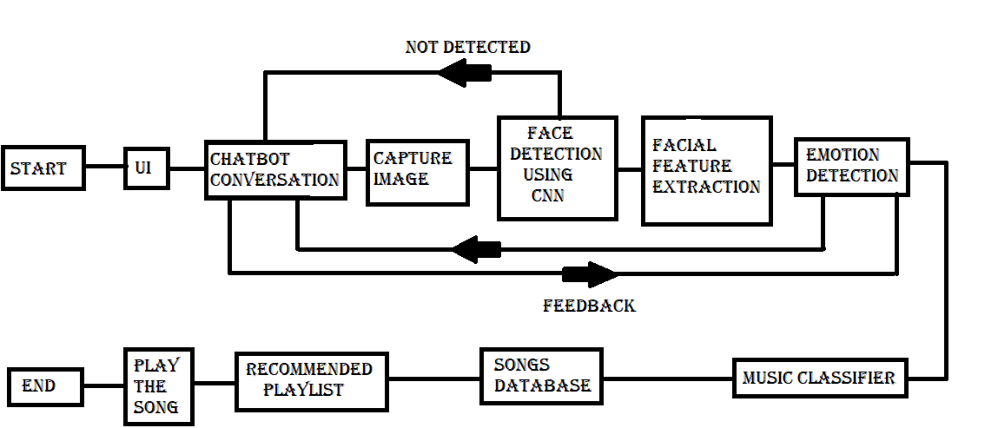

**Fig. DFD Diagram of Project**

**Above is the Data Flow Diagram of the proposed project program. In this, after the stating of program, a User Interface will appear. This will work as a plateform for chatbot to work. After some conversation Image of the user will start to capture.**

**If face isn’t detected, feedback will be given through chatbot.**

**When face is recognized emotion detection by facial feature extraction will start. Detected mood will be confirmed by user. Then , songs related to the mood will be classified.**

**Playlist of related songs will be fetched from Songs database. A song will be played from the recommended playlist. The program will end after all queries.**

**Page No. 8**

**Tools/Technology Used:-**

**1 Hardware Tools:**

1. **Processor : Intel core i-5**
2. **Storage – 512 SSD**
3. **RAM- 16 GB DDR4**
4. **WEBCAM – 5 MP**

**2 Software Tools:**

* **Operating System – Microsoft Windows 10**
* **Platform – Jupyter Notebook, V S Code**
* **Back End: Open CV, Keras, Spotipy**
* **Front End : HTML, CSS, JS**
* **Language : Python 3**

**Technologies:**

* **Software – Web Development**
* **Artificial Intelligence – A Chatbot system uses conversational AI to stimulate a discussion (or a chat) with a user in natural language (English) via messaging apps, websites, mobile apps, etc.**
* **Deep Learning – The data face print stored via facial traits is compared by the face recognition software using deep learning algorithms. Algorithms like SVM, RF, and KNN were used for emotion intensity recognition.**
* **Computer Vision –Computer Vision is a field of AI that trains computers to capture and interpret information from image and video data. By applying Deep Learning models to images, computers can classify objects and respond.**
* **Image Recognition & Face Recognition – Image recognition is the ability of program to make machine to identify objects, places, people, writing and actions in images. Computers can use machine vision technologies in combination with a camera and AI to achieve image recognition. Face Detection is an AI based computer technology used to find and identify human faces in digital images.**

**Page No. 9**

**References:-**

* **Geeks for Geeks -** [**https://www.geeksforgeeks.org**](https://www.geeksforgeeks.org)
* **Ijert -** [**https://www.ijert.org/research/mood-based-music-recommendation-system-IJERTV10IS060253.pdf**](https://www.ijert.org/research/mood-based-music-recommendation-system-IJERTV10IS060253.pdf)
* **Towardsdatascience -** [**https://towardsdatascience.com/build-your-first-mood-based-music-recommendation-system-in-python-26a427308d96**](https://towardsdatascience.com/build-your-first-mood-based-music-recommendation-system-in-python-26a427308d96)
* **Buildmedia -** [**https://buildmedia.readthedocs.org**](https://buildmedia.readthedocs.org)

# Applied DL & CV for Images & Video Data Analysis from Eduxlabs

* <https://www.eduxlabs.com/live-dl-cv-training>
* **Edureka! -** [**https://www.youtube.com/watch?v=G1Uhs6NVi-M&t=565s**](https://www.youtube.com/watch?v=G1Uhs6NVi-M&t=565s)
* **Intellipaat -** [**https://www.youtube.com/watch?v=FV3IvHeuH_k&t=364s**](https://www.youtube.com/watch?v=FV3IvHeuH_k&t=364s)
* **Codebasics -** [**https://www.youtube.com/watch?v=zfiSAzpy9NM**](https://www.youtube.com/watch?v=zfiSAzpy9NM)
* **CodeWithHarry -** [**https://www.youtube.com/watch?v=RhEjmHeDNoA**](https://www.youtube.com/watch?v=RhEjmHeDNoA)

**Page No.10**